Ionization energy is lowest for
A. Inert gases
B. Alkali metals
C. Halogens
D. Alkaline earth metals
ANSWER: B

The ionization energy from $Li$ to $Cs$
A. Decreases
B. Increases
C. Remains same
D. None of the above
ANSWER: A

Ionization potential value of group $II A$ when compared with $I A$ is
A. Lesser
B. Greater
C. Equal
D. None of the above
ANSWER: B

The ionization energy of nitrogen is more than oxygen because of ________.
A. More attraction of electrons by the nucleus
B. More penetration effect
C. The extra stability of half-filled p-orbitals
D. The size of the nitrogen atom is smaller
ANSWER: C
Why the value of atomic radius decreases from left to right in the periodic table?
A. Constant number of shells increases the effective nuclear charge
B. Constant number of shells decreases the effective nuclear charge
C. Decreasing the number of shells increases the effective nuclear charge
D. Increasing the number of shells decreases the effective nuclear charge
ANSWER: A
Which of the following statement is correct for electrical conductivity?
A. It decreases from top to bottom
B. It decreases from left to right due to the absence of free electrons
C. It increases from top to bottom due to the presence of free electrons
D. Both B & C
ANSWER: D
Which of the following decreases while going left to right in a period of the modern periodic table?
A. Atomic size
B. Atomic number
C. Metallic character
D. Both A & C
ANSWER: D
Which of the following statement is correct about electronegativity?
1. It decreases on going down in any group
2. It increases from left to right in a period
Select the correct option
A. 1 only
B. 2 only
C. 1 and 2
D. None of the above
ANSWER: C

Melting and boiling point depends upon
A. Inter atomic forces
B. Intermolecular forces
C. Structure or state
D. All of these
ANSWER: D

Which among the following is the least electronegative element?
A. Li
B. F
C. S
D. O
ANSWER: A

Which of the following is a semiconductor?
A. Sodium
B. Magnesium
C. Aluminum
D. Silicon
ANSWER: D

Why silicon has high melting and boiling point?
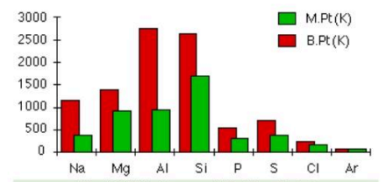
A. It is semiconductor
B. It contain strong vander waal forces
C. It has a giant covalent structure
D. All of these
ANSWER: C

Which of the following are good conductor of electricity?
A. Sodium
B. Magnesium
C. Aluminum
D. All of these
ANSWER: D
Which of the following do not conduct electricity?
A. Diamond
B. Silicon
C. Both A & B
D. Phosphorus
ANSWER: D
Which of the following has the largest ionization potential value?
A. $K$
B. $Na$
C. $Rb$
D. $Cs$
ANSWER: B

